UNIT II TOOL – BASED ASSIGNMENT

Arunagiri R
24BAD013

Tableau Assignment – Visualizing the Decision
Objective
The objective of this assignment is to create an interactive Tableau dashboard using the Superstore sales dataset. The dashboard helps analyze sales based on geographical location, product category, and time. It demonstrates OLAP operations such as drill-down, roll-up, slice, and dice.
Worksheets Created
Three worksheets were created in Tableau:
- Sales Map – Displays sales geographically using states and regions.
- Sales by Category – Shows total sales for Furniture, Office Supplies, and Technology using a bar chart.
- Sales Trend – Displays sales variation over months using a line chart.
OLAP Operationsi
Drill-Down
A geographical hierarchy Region → State → City was created. Drill-down allows the user to move from a broad regional view to detailed state and city-level information.
Roll-Up
Roll-up is the reverse of drill-down. It summarizes detailed information from City → State → Region, allowing the user to view sales at a higher level.
Slice
A Category filter was added to allow the user to select a single category such as Furniture, Office Supplies, or Technology. This represents the slice operation.
Dice
The dashboard can be used to analyze a combination of values, such as selecting a particular category along with a particular region. This represents the dice operation.
Dashboard and Decision Support
The Tableau dashboard combines the map, category bar chart, and sales trend into one interactive view. Filters and interactions help users compare sales across different regions, categories, and time periods. A manager can use this dashboard to identify high-performing regions and categories and make better sales decisions.
Type of Decision
The dashboard mainly supports a semi-structured decision because the data provides useful information and trends, but the manager still needs to use judgment and business knowledge to decide what action to take.
Conclusion
This assignment helped demonstrate how Tableau can transform raw sales data into meaningful visual information. The dashboard makes it easier to identify sales patterns, compare categories and regions, and support business decision-making through interactive visual analytics.

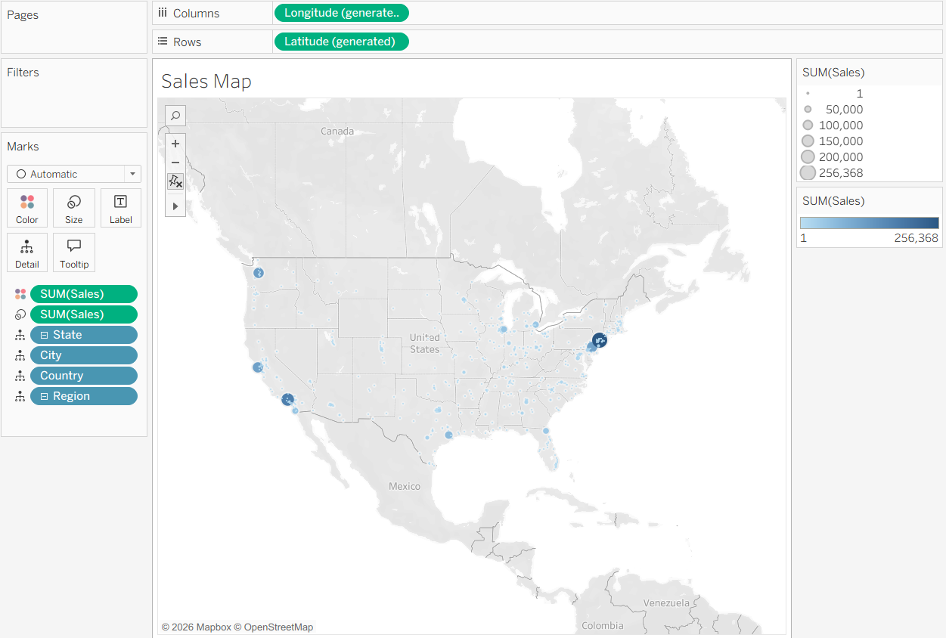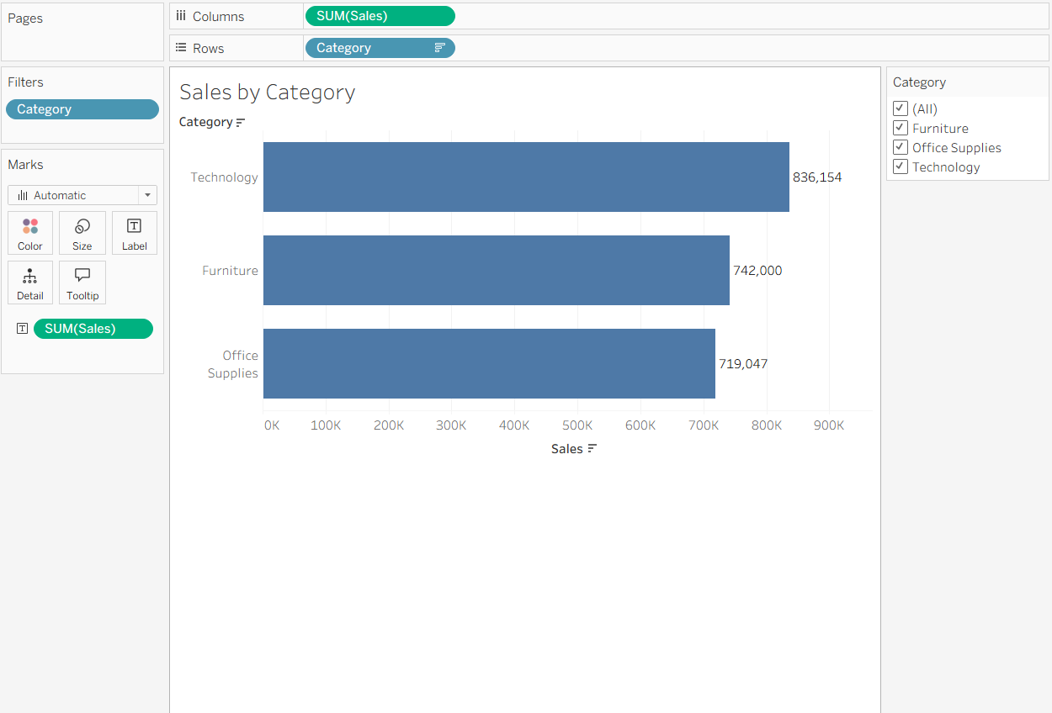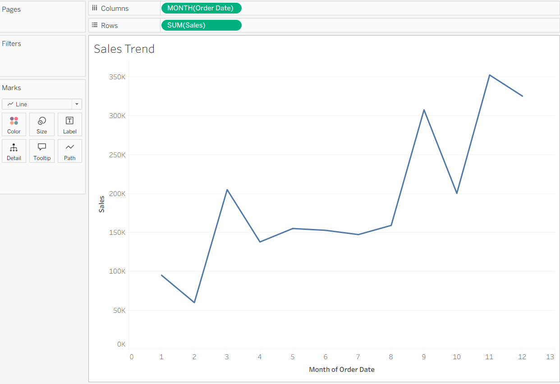

Power BI Assignment – From Data Warehouse to Dashboard
Objective
The objective of this assignment is to create a small star-schema data model in Power BI and use it to demonstrate OLAP operations such as roll-up, drill-down, slice, and dice through interactive visualizations.
Data Model
The Superstore sales dataset was imported into Power BI and transformed using Power Query. The original flat table was separated into a Fact table and dimension tables.
The model contains:
- fact_Sales – contains Sales, Profit, Quantity, Discount, Order Date, Region, Category, and other transaction-level data.
- Dim_Product – contains Product ID, Product Name, Category, and Sub-Category.
- Dim_Region – contains geographical information such as Region, State, and City.
- Dim_Date – contains date-related information such as Year, Quarter, Month, and Date.
This structure represents a star schema, where the fact table is connected to the dimension tables.
OLAP Operations
1. Roll-Up
Roll-up summarizes data from a detailed level to a higher level. For example, sales can be summarized from City → State → Region or from Month → Quarter → Year.
2. Drill-Down
Drill-down provides more detailed information. For example, a user can move from Year → Quarter → Month to analyze sales in greater detail.
3. Slice
A slicer can be used to select a single Category, such as Technology. The report then displays information only for the selected category.
4. Dice
Dice filters data using a combination of values, such as selecting a particular Region and Category together. This allows users to analyze a smaller subset of the overall dataset.
Power BI Visualizations
A Matrix visual was created to compare sales across Region and Year/Quarter. The matrix supports drill-down and roll-up operations.
Slicers were added for:
- Category
- Region
These slicers allow users to interactively filter the report.
DAX Measures
A DAX measure such as Total Sales can be created to calculate overall sales:
Total Sales = SUM(fact_Sales[Sales])
A ranking measure can also be created using the RANKX function to rank products or regions based on total sales.
Decision Support
The Power BI report helps managers identify high-performing regions, categories, and products. By using interactive filters and drill-down features, managers can explore sales at different levels of detail and make informed business decisions.
Conclusion
This assignment demonstrated how Power BI, Power Query, data modelling, DAX, and interactive visualizations can be combined to convert raw sales data into a useful business intelligence dashboard. The star schema and OLAP operations make it easier to analyze sales trends and support effective decision-making.

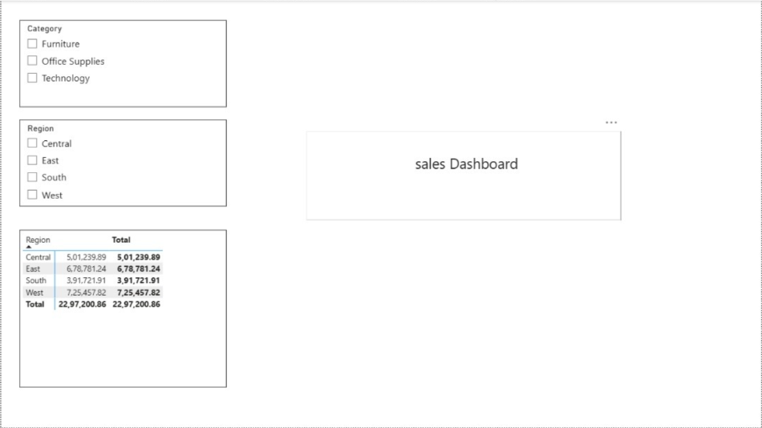

Google Colab Assignment – Clean, Transform, Analyze
Objective
The objective of this assignment is to use Google Colab and Python to clean, transform, and analyze a messy sales dataset. The dataset was processed using Pandas, and analytical functions were used to generate meaningful insights from the cleaned data.
Data Import
The sales dataset was imported into Google Colab using Python and the Pandas library. The dataset was examined to identify missing values, duplicate records, inconsistent formats, and possible outliers.
Data Cleaning
The following data-cleaning operations were performed:
- Missing values were identified and handled using an appropriate strategy.
- Duplicate records were checked and removed where necessary.
- Outliers were identified and handled appropriately.
- Inconsistent formats were standardized.
- Column names and data types were checked to ensure consistency.
Data Transformation
After cleaning, the dataset was transformed into a suitable format for business intelligence analysis. The data was grouped based on Region, Quarter, and Category, and important measures such as total Sales and Profit were calculated.
Analytical Functions
Pandas analytical functions were used to reproduce common SQL/window operations:
Rank
Sales were ranked within each region to identify high-performing categories or products.
Shift
The shift() function was used to compare the current period's sales with the previous period.
Cumulative Sum
The cumsum() function was used to calculate running or cumulative sales over time.
GroupBy
The groupby() function was used to summarize sales based on different dimensions such as Region, Quarter, and Category.
Gemini-Assisted Development
Gemini was used as an AI coding assistant to suggest Python/Pandas code for data cleaning, transformation, grouping, ranking, and analytical calculations. The generated code was reviewed carefully and modified whenever necessary instead of being accepted blindly.
Critical Review
AI-generated suggestions were useful for quickly developing the required Pandas operations. However, the generated code sometimes required corrections related to column names, data types, missing values, and grouping logic. Therefore, the output was tested and verified against the dataset before being used.
Reflection
This assignment helped me understand how raw and messy data can be transformed into a structured dataset suitable for business intelligence. I learned how to use Pandas for missing-value handling, duplicate removal, format standardization, grouping, ranking, shifting, and cumulative calculations. Gemini helped speed up the coding process by suggesting solutions and explaining functions. However, I learned that AI-generated code should always be checked because it may contain incorrect column names or assumptions about the dataset. Overall, the activity improved my understanding of both data preprocessing and AI-assisted programming.
